Where can you hear live music on Mondays, Wednesdays, Thursdays and Fridays?

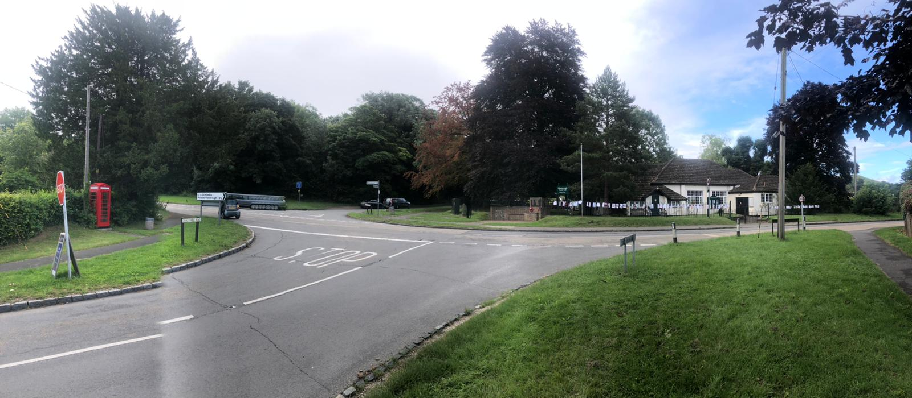

RIGHT HERE!

We are surrounded by people with so much talent, creativity, kindness and appreciation of our vibrant village. I will explain more in this first edition of our ‘Welcome to our Parish newsletter’. Let’s start with the Ellesborough Village Hall at the centre of our wonderful world! It is available

|  |  |  |  |
| --- | --- | --- | --- |
| Days of the week | AM | Afternoon | PM |
| MONDAY | A.T.H. (Available to hire) | 1-2.45pm Senior String Group | 7-9.30pm Blues & Jazz band named ’65.4’ average age of members |
| TUESDAY | Cleaning of hall | A.T.H. | 6.30-10.30pm Diamond Bridge Club from 17.8.21  (*Meetings also take place in Committee Rooms) |
| WEDNESDAY | 9-11am Pilates class by Emma Larner (school term time only) | A.T.H. | 6.45-7.45pm Pilates by E.L. (during term and non-term time) ***(Live music from Church Bells)*** |
| THURSDAY | A.T.H. | A.T.H. | A.T.H. ***(Live music from Russell Arms pub opposite)*** |
| FRIDAY | 3rd Fri/mth Coffee mornings – next one 20th August held in Committee Rooms Open to all ages. Run by Elizabeth Hine – Bookings Secretary. Tel No. 01296 625912 or lizziehine@talktalk.net | A.T.H. | 7-9pm Ellesborough Silver Band practise |
| SATURDAY & SUNDAYS |  | A.T.H. |  |

to hire @ £15/hr with use of all crockery, glasses, kitchen appliances, toilets etc. If a regular user 1st hr £15 then £12 extra hours. All hand sanitizer/wipes available but bring own face masks. Catering options can be provided by local branch of W.I. starting from cream teas @£6.50/head.

**North** takes us to Buckmoorend Farm Shop & Kitchen & Chequers



**West** to Wendover **East** to Ellesborough Church

**South** to travel down Chalkshire Road & beyond where HS2 lurks

NORTH - Buckmoorend Farm Shop & Kitchen [www.buckmoorendfarm.co.uk](http://www.buckmoorendfarm.co.uk)

Chequers – the Prime Minister’s country retreat surrounded by wonderful public footpaths, cycle ways, bridleways and views across the valley and beyond. If a keen walker then you may be interested in joining the Aylesbury branch of Ramblers Association or Chiltern Society. Our local journalist, Sandra Smith keeps us up to date with weekly activities in the Wendover Neighbourhood News section of The Bucks Herald newspaper.

Centre - Meetings take place in our Ellesborough Parish Hall by our caring and hard working Village Hall Committee and our Ellesborough Parish Council. The E.P.C. have recently updated their website [www.ellesborough.org.uk](http://www.ellesborough.org.uk) and if new to the area you will probably want to refer to the Village Design Statement found on the website within the Parish Council, Policies sub section for guidance regarding planning and design developments. Behind the EPH is a lovely, enclosed playground with traditional children’s playground and adult fitness equipment plus space for a picnic on a sunny day.

Opposite is The Russell Arms pub which is a real village pub and restaurant [www.therussellarms.co.uk](http://www.therussellarms.co.uk) They stock supplies of winning ales from our award winning Chiltern Brewery [www.chilternbrewery.co.uk](http://www.chilternbrewery.co.uk)

Adjacent is the bus stop with a variety of bus services being run by Arriva and Red Line. The Kimbles & Ellesborough Risborough Area Community Bus (green one, Route 6) has been reintroduced since 26th July [www.racb.co.uk](http://www.racb.co.uk) or ring 07941 963 097. Local taxi services including Wendover Taxis on 01296 350196 [www.wendovertaxi.co.uk](http://www.wendovertaxi.co.uk) are available to get you from A to B – especially if you are getting the last train back from London in to Wendover Station.

EAST - Ellesborough Church has beautiful views both inside and out plus the benefit of cream teas being served on a Sunday afternoon. In the distance is Great Kimble C of E School with strong links to the village.

SOUTH – Travelling down Chalkshire Road you will pass Three Areas – the home of Rex Norris, our Parish Clerk and his wife Liz who runs a knitting club. Further down on the same side of the road, just past Royal Mead is Ellesborough Recreational Ground with the allotments alongside. Did you know that if you run round the playing field four times you have run just over a mile? Continue down Chalkshire Road and you will find The Plough and their gardens, along with several others in the village are often open to the public to raise money for charity. Travelling out of the village is the Jet Garage which is open long hours and stocks many useful items as well as fuel. Further on is the Freemantle Nursing Home where several, elderly members of our community now live and with the Covid restrictions lifting hopefully will soon be able to receive visitors again from friends of all ages.

WEST – Before reaching Wendover you will pass Ellesborough Golf Course which will appeal to those who play and those who walk dogs across the footpath and want to admire the views. Once having reached the town itself there is a wealth of cafes, variety of restaurants, supermarkets, pubs, gift shops, boutiques, antique shops, a local market on a Thursday, hairdressers, cricket ground, park and beautiful churches to frequent. There is also a Tourist Information Booth by the clock tower to help you find more things to do if you run out of ideas. If problems with your computer or you want to get one then Pete at Wendover Computers may be able to help you [www.wendover-computers.co.uk](http://www.wendover-computers.co.uk) There is also a large library with a range of knowledgeable staff who may also be able to help you get to know the area better.

Further on is Dobbies Garden Centre and to the left hand side behind a wooden fence is Lindengate [www.lindengate.org.uk](http://www.lindengate.org.uk) and their gardens help to restore and heal our mental health. They are now open to the public on Saturday afternoons.

NEWSFLASH!! Annual Honey Show run by Mid Bucks Bee Keepers Association taking place in our Ellesborough Parish Hall on Saturday 4th September from 10-4pm.

I hope you have found Welcome 1 Newsletter useful and I will write a fresh one in the next quarterly edition of this magazine.

